Name: ____________________________________ Class: __________________ Date: ____________

Unit 10 Review

An isometry is a transformation that preserves length and angle measure.

Translations, reflections, and rotations are all transformations that are isometries.

Dilations are the only transformation that is not an isometry.

**Translations (9.1)**

A translation moves every point of a figure the same distance in the same direction.

(2, 6) means the point (2, 6)

(x, y) → (x + 2, y + 6) is a translation in coordinate notation that moves every point 2 units to the right and 6 units up.

 is a vector in component form that moves every point 2 units to the right and 6 units up.

**Use the translation (x, y) → (x + 6, y – 3).**

1. What is the image of A (3, 2)? 2. What is the preimage of B’ (2, -7)

A’ (9, -1) B (-4, -4)

**A’B’C’ is the image of** **ABC after a translation. Write a rule for the translation in coordinate notation.**

3. (x, y) → (x – 5, y + 3) 4. (x, y) → (x + 2, y – 5)

**Name the vector and write its component form.**

5.  6. 

**Use the point P (5, -2). Find the component form of the vector that describes the translation to P’.**

7. P’ (2, 0) 8. P’ (8, -3)

 

**Reflections (9.3)**

If (a, b) is reflected in the x-axis, its image is the point (a, -b).

If (a, b) is reflected in the y-axis, its image is the point (-a, b).

If (a, b) is reflected in the line y = x, its image is the point (b, a).

If (a, b) is reflected in the line y = -x, its image is the point (-b, -a).

**Graph the reflection of the polygon in the given line.**

9.  10. 

**Rotations (9.4)**

For a rotation of 90o counterclockwise, (a, b) → (-b, a).

For a rotation of 180o counterclockwise, (a, b) → (-a, -b).

For a rotation of 270o counterclockwise, (a, b) → (b, -a).

Rotating a figure 90o clockwise is the same as rotating it 270o counterclockwise.

Rotating a figure 180o clockwise is the same as rotating it 180o counterclockwise.

Rotating a figure 270o clockwise is the same as rotating it 90o counterclockwise.

**Rotate the figure the given number of degrees about the origin. List the coordinates of the vertices of the image.**

11.  12. 

A’(-1, -3), B’(-3, -3), C’(-1, 1), D’(-3, 1) A’(2, 0), B’(4, -1), C’(4, -6), D’(2, -5)

**Symmetry (9.6)**

A line of symmetry for a figure is a line in which you can fold the figure to map it onto itself.

**Draw a figure for each description below. If not possible, then write not possible.**

13. A triangle with exactly two lines of symmetry 14. A quadrilateral with exactly two lines of symmetry.

Not Possible

**Dilations (9.7)**

If the scale factor of a dilation is greater than one, then it is an enlargement. If the scale factor of a

dilation is less than one, then it is a reduction.

**Graph the points A (-2, 4), B (4, 6) and C (-6, -2). Then dilate them with the given scale factor, k, about the origin. Tell whether each dilation is a reduction or enlargement.**

15. k = 1/2; reduction 16. k = 3/2; enlargement

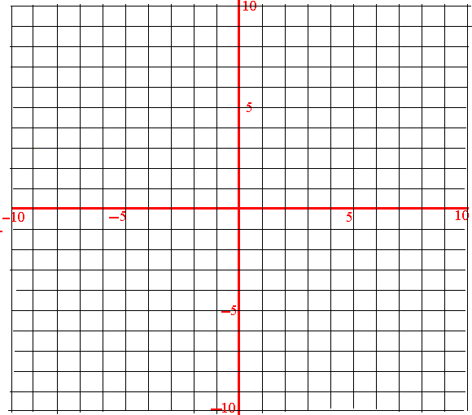 

**Find the scale factor. Tell whether the dilation is a reduction or an enlargement. Find the value of x.**

17. 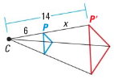 18. 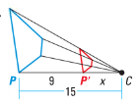

k = 7/3; enlargement; x = 8k = 2/5; reduction; x = 6

**Composition of Transformations (9.5)**

When performing a composition of transformations, draw **each** individual step in the **order** that they are listed.

**The vertices of** **ABC are A (3, 1), B (1, 5), and C (5, 3). Graph the image of** **ABC after a composition of transformations in the order that they are listed.**

19. Translation: (x, y) → (x + 3, y – 5) 20. Translation: (x, y) → (x – 6, y + 1)

Reflection: in the y-axis Rotation: 90o about the origin

 

**Graph**  **after a composition of transformations in the order they are listed.**

21. F (4, -4), G(1, -2) 22. F (-1, -3), G(-4, -2)

Rotation: 90o about the origin Reflection: in the line x = 1

Reflection: in the y-axis Translation: (x, y) → (x + 2, y + 10)

 

**Describe the composition of transformations.**

21. 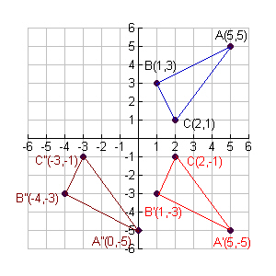 22. 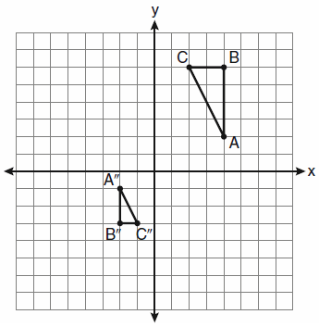

1) Reflect in x-axis; 2) Translate (x, y) → (x – 5, y) 1) Dilation w/ scale factor of 1/2; 2) Rotation 180o