Name __________________________________ Date _______________ Period ___

Extra Quadratic Function Graphs & Equations Practice
#1  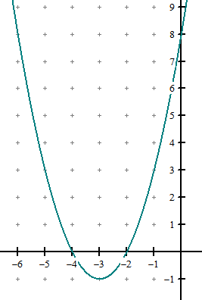 | a. Parabola opens ___________  b. Vertex: ________________  c. The vertex is a ____________  d. Equation for the axis of  symmetry: ______________  e. Y-intercept: _____________  f. X-intercept(s): ___________ | g. Quadratic Equation:
#2  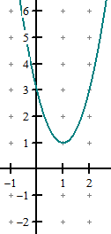 | a. Parabola opens ___________  b. Vertex: ________________  c. The vertex is a ____________  d. Equation for the axis of  symmetry: ______________  e. Y-intercept: _____________  f. Root(s): ___________ | g. Quadratic Equation:
#3  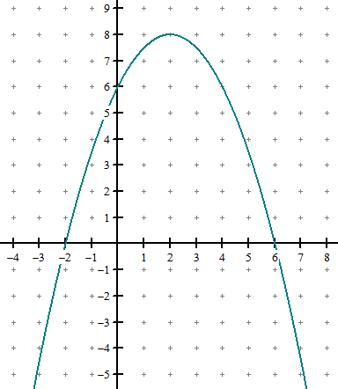 | a. Parabola opens ___________  b. Vertex: ________________  c. The vertex is a ____________  d. Equation for the axis of  symmetry: ______________  e. Y-intercept: _____________  f. Solution(s): ___________ | g. Quadratic Equation:
#4  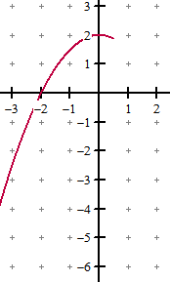 | a. Parabola opens ___________  b. Vertex: ________________  c. The vertex is a ____________  d. Equation for the axis of  symmetry: ______________  e. Y-intercept: _____________  f. Zero(s): ___________ | g. Quadratic Equation:
#5  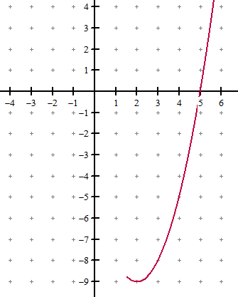 | a. Parabola opens ___________  b. Vertex: ________________  c. The vertex is a ____________  d. Equation for the axis of  symmetry: ______________  e. Y-intercept: _____________  f. X-intercept(s): ___________ | g. Quadratic Equation:
#6  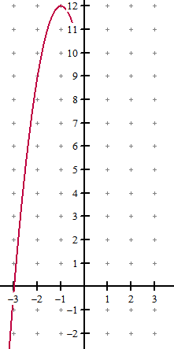 | a. Parabola opens ___________  b. Vertex: ________________  c. The vertex is a ____________  d. Equation for the axis of  symmetry: ______________  e. Y-intercept: _____________  f. Solution(s): ___________ | g. Quadratic Equation:

